**Date: 20.08.25**

**TASK:5**

**Implementation of Ant Colony Optimization to find the shortest and most efficient route for ride-sharing/delivery services using Python**

Implementation of Ant Colony Optimization to Optimize Ride-Sharing Trip Duration using Python by following constraints.

•To forecast travel times between every pair of pick-up and drop-off locations.

•To find the shortest route that visits a set of locations.

•To implement optimization techniques are required to intelligently search the solution space and find near-optimal solutions.

**Tools: Python**

**PROBLEM STATEMENT: CO2 S3**

A logistics company is trying to improve the efficiency of its delivery trucks by minimizing the total travel distance required to visit multiple customer locations. Each truck must start from the depot, deliver to every customer exactly once, and return to the depot. The road network is represented as a distance matrix between all customer locations. Since finding the shortest possible route is a complex combinatorial optimization problem, the company decides to use the Ant Colony Optimization (ACO) algorithm. The algorithm simulates the behavior of ants searching for food, where ants explore different routes and deposit pheromones on shorter paths. Over time, the pheromone trails guide future ants to choose better routes, leading to the discovery of a near-optimal delivery path that reduces fuel consumption, delivery time, and overall operational cost.

**ANT COLONY OPTIMIZATION**

**AIM**

To implementation of Ant Colony Optimization to find the shortest and most efficient route for ride-sharing or delivery services using Python

**ALGORITHM**

* 1. Initialize pheromone levels on all routes.
  2. Place ants at the starting city
  3. For each ant:

Build a path by moving to the next city based on:

Pheromone strength (experience).

Visibility (shorter distance is preferred).

* 1. Calculate the total distance (cost) of each ant’s path.
  2. Update pheromones:

Evaporate some pheromone on all paths.

Add pheromone to the paths used by ants (better paths get more).

6.Repeat steps 3–5 for a number of iterations.

7. Return the best path and its cost found during the process.

**PROGRAM**

**Delivery optimization using Ant Colony Optimization**

import numpy as np

from numpy import inf

# Distance matrix between depot + customer locations

# 5 cities (1 depot + 4 customers)

d = np.array([[0, 10, 12, 11, 14],

[10, 0, 13, 15, 8],

[12, 13, 0, 9, 14],

[11, 15, 9, 0, 16],

[14, 8, 14, 16, 0]])

iteration = 100 # number of iterations

n_ants = 5 # number of ants

n_citys = 5 # number of cities

# Parameters

e = 0.5 # evaporation rate

alpha = 1 # pheromone influence

beta = 2 # visibility influence

# Visibility = 1/distance

visibility = 1 / d

visibility[visibility == inf] = 0

# Initial pheromone levels

pheromone = 0.1 * np.ones((n_citys, n_citys))

# Routes for ants

routes = np.ones((n_ants, n_citys + 1))

for ite in range(iteration):

routes[:, 0] = 1 # all ants start at city 1

for i in range(n_ants):

temp_visibility = np.array(visibility)

for j in range(n_citys - 1):

cur_loc = int(routes[i, j] - 1)

temp_visibility[:, cur_loc] = 0

# pheromone and visibility contributions

pheromone_feat = np.power(pheromone[cur_loc, :], alpha)

vis_feat = np.power(temp_visibility[cur_loc, :], beta)

prob = pheromone_feat * vis_feat

prob = prob / prob.sum() # normalize

cum_prob = np.cumsum(prob)

r = np.random.random()

city = np.nonzero(cum_prob > r)[0][0] + 1

routes[i, j + 1] = city

# last city not visited

left = list(set([i for i in range(1, n_citys + 1)]) - set(routes[i, :-2]))[0]

routes[i, -2] = left

route_opt = np.array(routes)

dist_cost = np.zeros((n_ants, 1))

for i in range(n_ants):

s = 0

for j in range(n_citys - 1):

s += d[int(route_opt[i, j]) - 1, int(route_opt[i, j + 1]) - 1]

dist_cost[i] = s

dist_min_loc = np.argmin(dist_cost)

dist_min_cost = dist_cost[dist_min_loc]

best_route = routes[dist_min_loc, :]

pheromone = (1 - e) * pheromone

for i in range(n_ants):

for j in range(n_citys - 1):

dt = 1 / dist_cost[i]

pheromone[int(route_opt[i, j]) - 1, int(route_opt[i, j + 1]) - 1] += dt

print("Routes of all ants at the end:")

print(route_opt)

print("\nBest Path:", best_route)

print("Cost of the Best Path:", int(dist_min_cost[0]) + d[int(best_route[-2]) - 1, 0])

**OUTPUT**

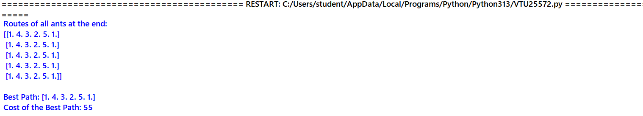

**RESULT**

Thus, the implementation of Ant Colony Optimization to find the shortest and most efficient route for ride-sharing or delivery services using Python was successfully executed and output was verified